Department of Physics / Umeå University

Double column Template
John Smith^{1*}, Jennie Smith¹
Abstract
The thin lens equation can predict how lenses in an optical system refract light. In this exercise, we investigated how well our theoretical predictions coincided with our experimental findings. What was done? Using the thin lens equation, we first derived the distance to the image plane for an object positioned in front of a convex and concave lens and thereafter experimentally measured the the distances. How was it done? We found that the experiments agreed with the theoretical predictions, with a discrepancy of only 1.0 ± 0.2 mm. What was found? We then built and verified the performance of both a Kepler and a Galilean telescope. We found that theory and experiment coincided with a discrepancy of 3.0 ± 0.3 mm. However, we observed a significant amount of aberrations, which we suggest is related to the spherical lenses used in the setup. The findings in this exercise suggest that the thin lens equation can accurately predict how lenses should be positioned for imaging purposes, but that it does not take into account the degree of aberrations. What is the significance of the findings?.
Keywords
Optics – Interference – Diffraction
¹Department of Physics, Umeå University, Umeå, Sweden
Corresponding author: john@smith.com
Supervisor: joe@doe.com

Contents
1. Introduction 1
2. Methods 1
2.1. Theory 1
2.2. Experimental procedure 2
3. Results 2
3.1. Verification of the thin lens equation 2
3.2. Chromatic aberrations 2
4. Discussion and Conclusion 2
5. References 2

Introduction
The thin lens equation provides the quantitative relationship between the object distance, the focal length, and the image distance. We investigated how well this equation could predict the refraction of light in optical lenses. Identifies the scientific concept which forms the learning context for the lab. The thin lens equation, which is also denoted the Gaussian lens formula, was derived by Edmund Halley in 1693 under the assumption that the thickness of the lens is ignored and that the paraxial assumption is used [1]. This simplifies ray tracing calculations but give rise to errors if the rays are focused by the outer part of a lens [2]. Background of the scientific concept Therefore, we assumed to have some discrepancy between the theoretical and experimental values.
Our main objective was to theoretically calculate the relation between the position of the object and image plane for a number of lenses and a train of lenses, and thereafter verify the calculations using a set of real lenses. The calculations were also compared to manually drawn ray-tracing diagrams using pen and paper. Paragraph that identifies the objectives in the lab

Methods

Theory
The thin lens equation can be derived from the thick lens equation [3]. By denoting s and s’ as the object and image distances, respectively, and s_{i1} as the image distance due to refraction in the first surface a relation can be expressed as,
$\frac{n_{m}}{s}+\frac{n_{m}}{s^{'}}=\left(n_{1}-n_{m}\right)\left(\frac{1}{R_{1}}-\frac{1}{R_{2}}\right)+\frac{n_{1}d}{\left(s_{i1}-d\right)s'}$, (1)
where n_{m} and n₁ are refraction index for the glass and air, respectively…

Experimental procedure
We used a small light emitting diode as an object and imaged it on a white 10x5 cm² screen, using different lenses. The lenses were made of glass and either biconvex or biconcave with a diameter of 7.0 cm. All components; the diode, lenses, and the screen were mounted in sliding holders, which could be moved and locked on a metal rail for accurate positioning. An illustration of the setup is shown in Figure 1.
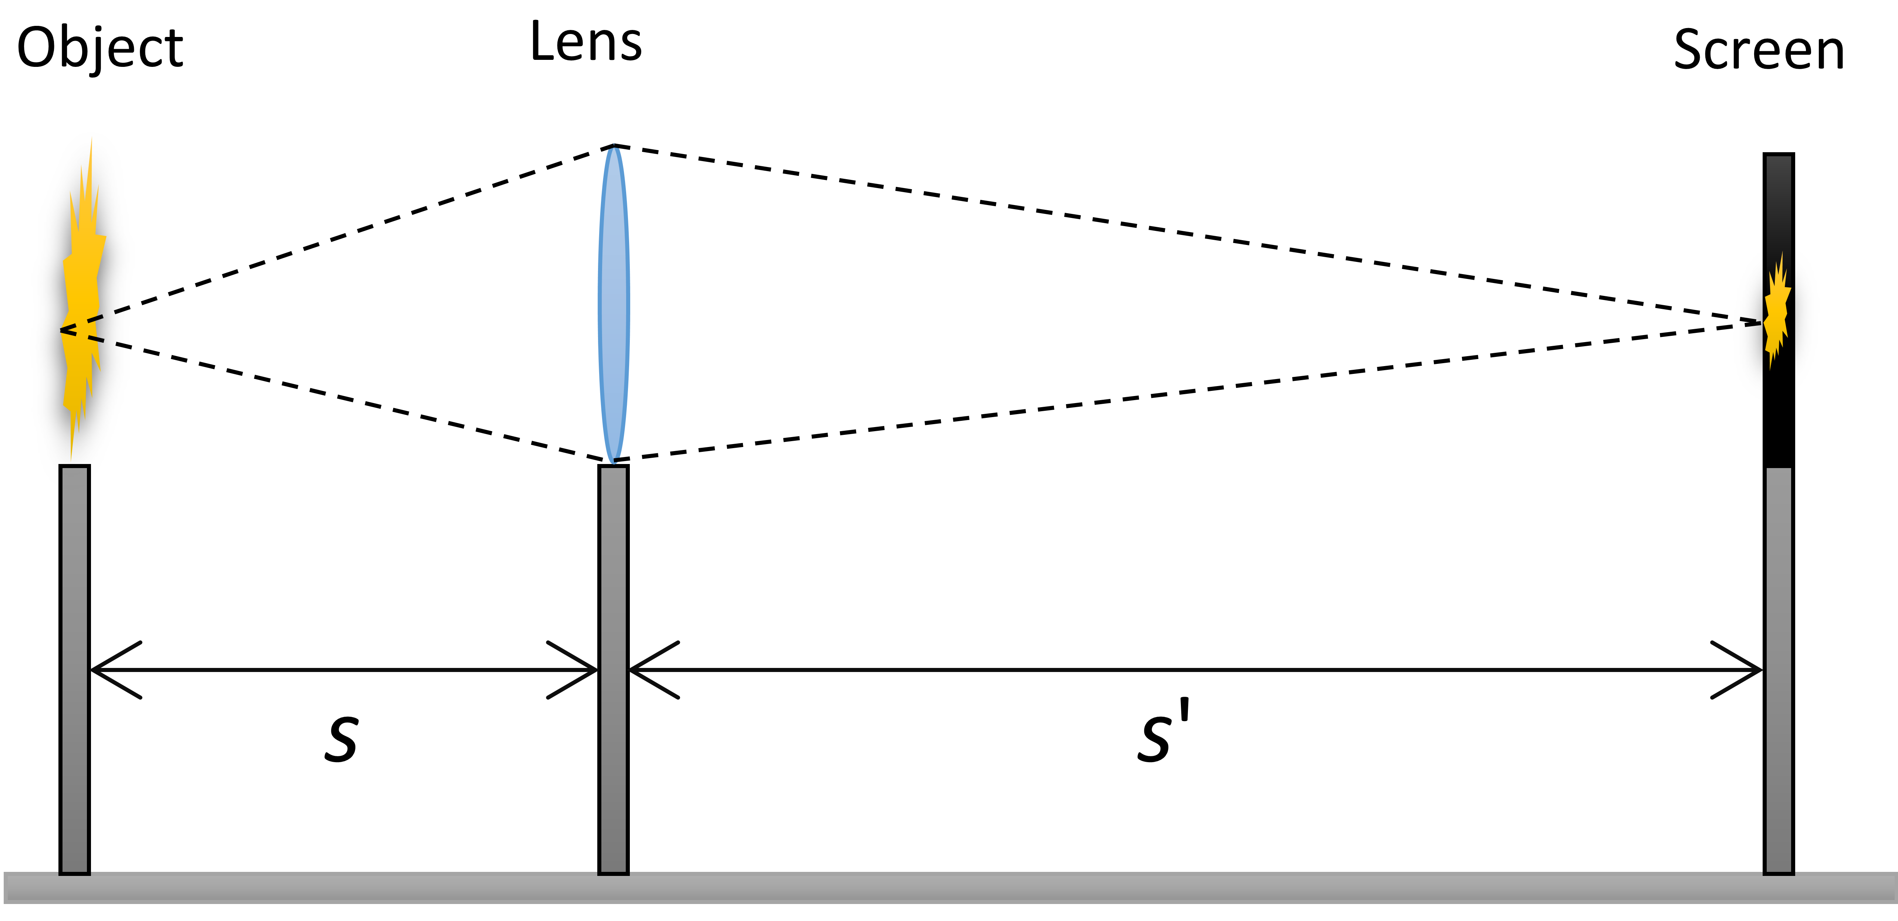
Figure 1. Schematic of the setup used to mount the optical components (light emitting diode, lens, and screen) and measure how light was refracted by the lenses. A 5 mm light emitting diode was used as an object and the white screen was moved until a sharp image was seen. The distances were measured using a regular steel ruler.

Results

Verification of the thin lens equation
Our experimental findings are in good agreement with theoretical calculations. Start with a sentence that highlights the findings for each result, support this with facts. We first verified the thin lens equation of a concave and convex lens of 15.0 cm and -15.0 cm focal length, respectively. For an object distance of 25.0 cm we derived an image distance of 37.5 cm and 9.4 cm.

Chromatic aberrations
Chromatic aberrations are a result of dispersion, that is the variation of the index of refraction of a medium with wave-length. The following text is not explaining this but is just placed here to fill the page. Figure 3 is also just a dummy figure and is placed there to show how a figure can be neatly positioned across two columns.
Etiam euismod. Fusce facilisis lacinia dui. Suspendisse potenti. In mi erat, cursus id, nonummy sed, ullamcorper eget, sapien. Praesent pretium, magna in eleifend egestas, pede pede pretium lorem, quis consectetuer tortor sapien facilisis magna. Mauris quis magna varius nulla scelerisque imperdiet. Aliquam non quam. Aliquam porttitor quam a lacus. Praesent vel arcu ut tortor cursus volutpat. In vitae pede quis diam bibendum placerat. Fusce elementum convallis neque. Sed dolor orci, scelerisque ac, dapibus nec, ultricies ut, mi. Duis nec dui quis leo sagittis commodo.

Discussion and Conclusion
The thin lens equation is an approximate equation that can predict the distance from a lens to an image, given the distance from an object. Using this equation, we investigated and compared the accuracy between theoretical prediction with experimental data. One to three sentences to introduce what was done.
The theoretical and experimental results for the concave and convex lenses agreed well, however, the theoretical values were slightly overestimated. We suggest that this overestimation is due to the rather large-sized lenses used in the exercise.

References
[1] Steinhaus, H., Mathematical Snapshots, 3rd Edition. New York: Dover, pp. 93-94, (1999)
[2] Greivenkamp, J. E., Field Guide to Geometrical Optics, SPIE Press, Bellingham, WA (2004)
[3] Pedrotti, F.L. and Pedrotti, L.S., Introduction to Optics, 3rd Edition, Addison-Wesley, (2006)
Appendix
This sample report can hopefully be of help when you write your report. Remember that writing is a craft and requires a lot of practice. Use the information found in Att skriva och presentera rapporter, which gives you detailed advice of each section of a report. If you are interested in improving your writing skills, we recommend you to read the book by Joshua Schimel - Writing Science: How to Write Papers That Get Cited and Proposals That Get Funded. 2011. Oxford University Press. Another great book that we recommend is the book by Joseph M. Williams -Style - Lessons in Clarity and Grace.
To generate a Reference for a website or article there are several generators that you can use. For example:
http://www.harvardgenerator.com/ or http://www.qub.ac.uk/cite2write/harvard3l.html

